**Meeting of the Waterbury Recreation Committee**

**Tuesday 4/22/2025**

**Steele Community Room**

**Scheduled Duration 6:30 – 8:00 PM**

Topic: Town of Waterbury's Rec Committee

Time: 4/22/2025 06:30 PM Eastern Time (US and Canada)

Meeting ID: 864 2725 3173

Passcode: 840917

Find your local number: https://us06web.zoom.us/u/ksDx70ZN3

1. Roll Call:
   1. Committee Members: Frank Spaulding, Paul Lawson,

Phoebe Pelkey, Beth Gilpin, Jake Ferreira, Aaron Starmer,

Emma Lenchner, Brian Cooke, Alex Showerman, Brooks Fortune

* + 1. Present: Frank Spaulding, Paul Lawson, Beth Gilpin, Aaron Starmer, Emma Lenchner, Brian Cooke, Brooks Fortune

ii.Absent: Alex Showerman, Jake Ferreira, Phoebe Pelkey,

1. Town Employees – Officers: Roger Clapp, our new designated liaison to the SB
   * 1. Guests: none

1. Adopt Meeting Agenda:
   1. Motion to adopt: Paul Lawson
   2. Second: Emma Lenchner
   3. Discussion:
   4. Vote:
2. Adopt Meeting Minutes of 3/25/25
   1. Motion to adopt: Aaron Starmer
   2. Second: Paul Lawson
   3. Discussion: Minor discussion to distinguish between content related to the pool vs. the potential Anderson field project
   4. Vote:

4.Public Comments – This is a business meeting. The committee will limit public comments to 3 minutes per person or depending on the number of individuals who choose to speak no more than 15 minutes aggregate, divided evenly depending on the number of individuals.

Welcomed Brooks Fortune to the committee,

Frank shared a quick history of the recreation facility project and factors that led us to scale back but not stop looking to gather public input and see if we can find a way to build a modest building that meets some needs desired by a broad swath of the community.

1. Recreation Director Report

Town Plan – Rec submitted their piece in December. Katarina will follow up with the Town Planner to confirm it’s been included in the Town Plan input collected to date.

Next Town Plan development meeting is 5/29, hopefully held in partnership with RW at Black Cap.

1. Discussion about community connectivity partners

Alex proposed in the 3/25/25 meeting that we consider serving as a convener to help bring together and help facilitate meetings among members of these groups re: individual non-motorized trails connectivity projects. Could be a quarterly sub-committee.

Potential Benefits:

* Coordinate/strengthen ability to get funds
* Explore opportunities for greater efficiency by coordinating/communicating what groups are working on

Related note: RW working with WATA on an economic impact study of mountain and gravel biking on town’s economy and what investments need to be made to continue supporting that.

Next steps:

Invite groups to next meeting. Frank and Katarina will follow up with Alex to coordinate outreach.

See if Alex has a map of current and envisioned projects underway/being discussed.

Potential groups to invite: WATA, Community Path, Cold Hollow Group (Town/Planning Commission/LEAP, which recently got a VTrans grant), Cross Vermont Trail, RW, VT Huts, Velomont.

1. Recreation Center/Field house discussion

Katarina and Bill Woodruff visited new Colchester Recreation Center – two story building, 1 of only 2 workout gyms in Colchester. Been open 7 weeks.

Reviewed blueprint Katarina shared and insights about components, layout, materials, etc.

Next steps:

* Katarina meeting with Weiman and Lamphere in early- to mid-May to review several plans they’re drawing up based on the square footage we submitted to the Tom Leitz for sharing with W and L.

1. Discussion about roles/appointments/bylaws for committee members

Last review and modifications were in 2022. Good timing to revisit, especially with Frank Spaulding completing his three terms soon.

Next steps:

* Committee members should review and bring input to next meeting.
* May meeting: Come up with a process, timeline and structure for electing officers.
* Consider Length of service of chair and succession plan, e.g., natural selection to Vice Chair or a formal election, and what time of year is optimal?
* Re: ad hoc committees and liaison work – does it serve the committee well?

Roger Clapp: First meeting in May is a good time to elect officers given that it follows when new committee members are appointed by the select board.

1. Next meeting: Tuesday, May 27th

* See Agenda for 5/27/25

1. Adjourn
   1. Motion to adopt: Emma
   2. 2nd: Brian Cooke

Attachment A

Map of Colchester Recreation Facility

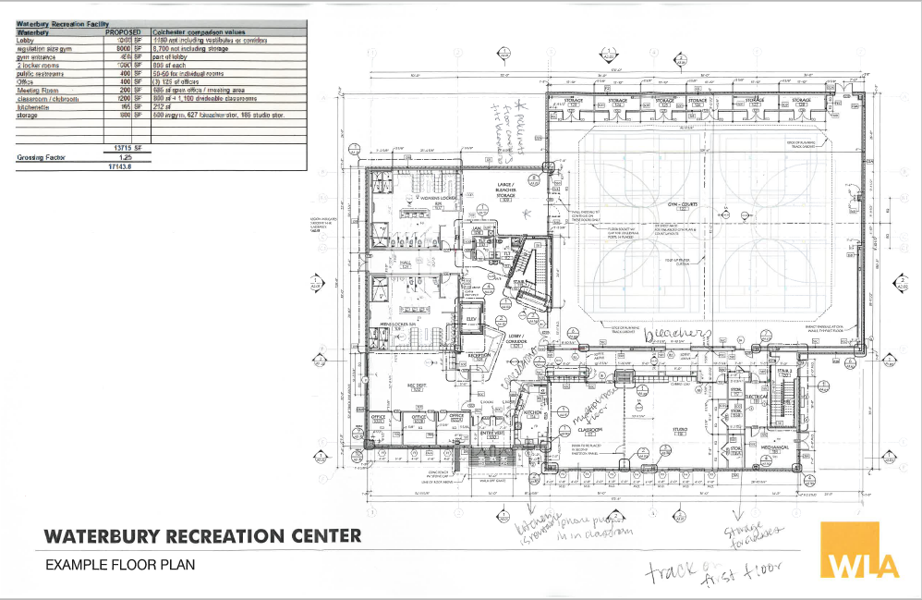

Attachment B

Recreation Center, Adjustment of Square Footage

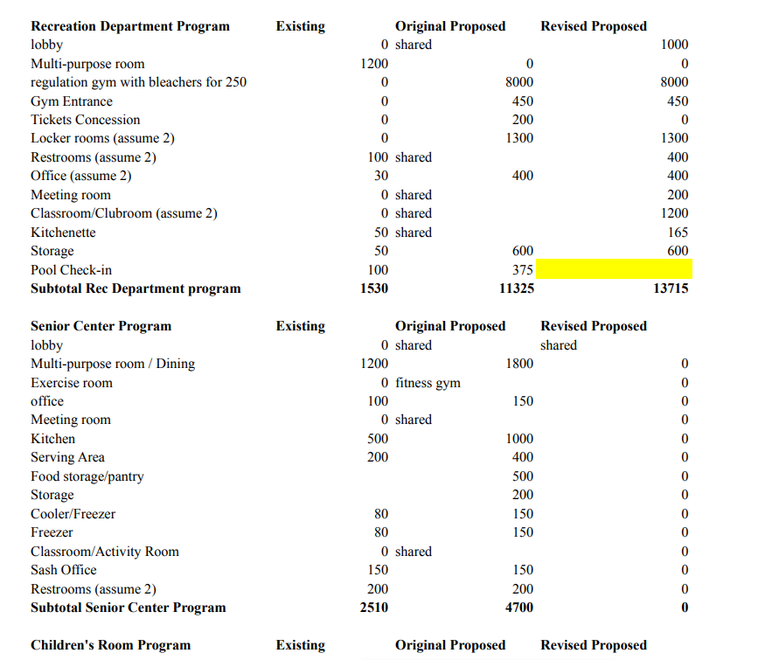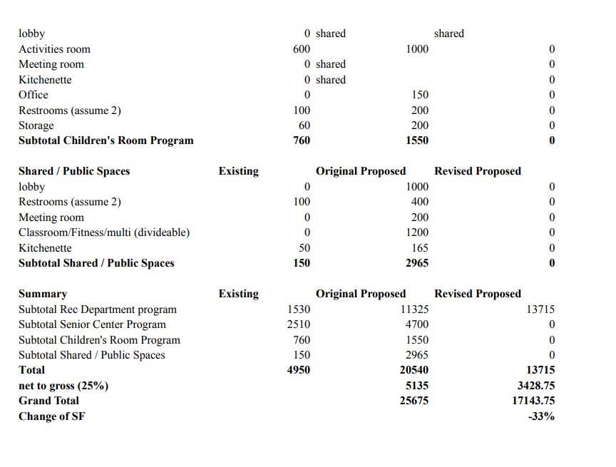

Attachment C

Square Footage

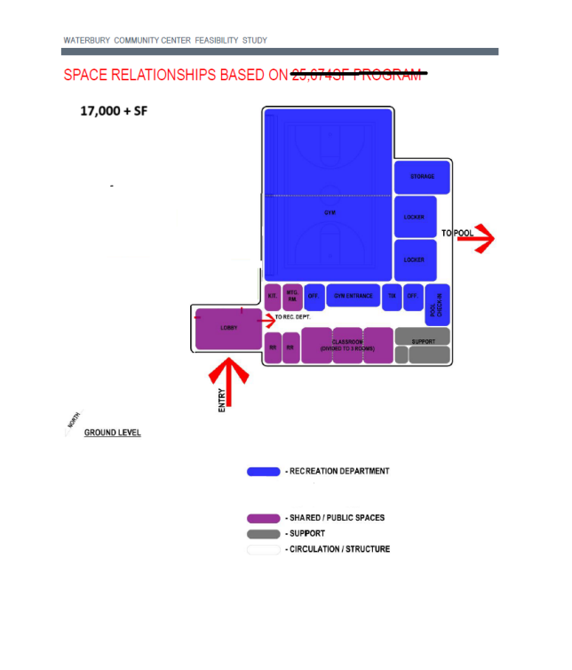

Attachment D

Recreation Committee Memo

