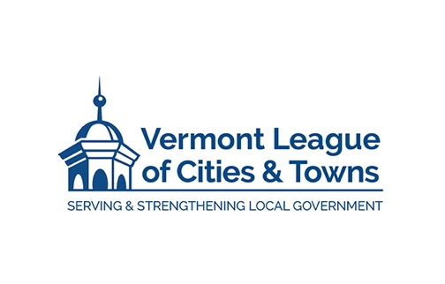
MEMORANDUM

To: Martha Staskus, Don Schneider, Waterbury Select Board
From: William Fraser, VLCT Management Consultant
Re: Municipal Manager Recruitment Plan
Date: April 15, 2026

Recruitment Plan
March 23-27 Sent questionnaires to Board
April 7 Contract Approved
April 8-17 Compiled responses, drafted candidate profile, drafted job advertisement, provided comparisons and salary recommendation, brochure draft sent
April 10 & 17 Met with Chair and Vice Chair
- Ad preliminarily approved
- Profile preliminarily approved
- Salary preliminarily approved at $125K to $145K
- Final schedule preliminarily approved
- Preliminary process decisions made

April 21 Select Board approves Recruitment Plan, Ad, Job Description, Profile, and Brochure with changes if desired

April 27 Ads posted in VLCT, NHMA, MMA websites and newsletters, ICMA website and newsletter, Town website, Waterbury Roundabout.

April 27-May 27 Recruitment Outreach by Consultant. Weekly update sent to Board by Consultant.

May 27 Applications due to Consultant

May 27 Citizen’s Committee applications due

May 28-30 Consultant provides Select Board all resumes with evaluation and summary memo. Memo will sort candidates into categories and make recommendations. Board makes final decision about which candidates move forward.

June 2 Board meets with Consultant in executive session to select semi-final candidates.

June 8-12 Board Chair, Vice Chair, and Consultant Interview Semi-Finalists, select Finalists. Consultant will coordinate scheduling and assist with interview outline.

June 15-19 Interview Finalists. Each finalist will be in Waterbury on a separate day. Tour of Waterbury for finalists will be conducted. Finalists will meet with staff team appointed by Board, 7 person community group appointed by Board, and the full Select Board in separate interviews. Consultant will coordinate scheduling and assist with interview outline.

After interviews, select top candidate. Make qualified offer.

June 12-26 VLCT conducts background check, reference checks, and employment negotiation. Written background and reference reports will be provided to Board.

June 30 Appoint Municipal Manager

These dates can be fluid depending on how many applications, how many interviews, how quickly people can be scheduled, how quickly Board makes decisions.

